**Programming Challenges #3 – Due on or before midnight Friday 5/10**

**Objective:** Single Dimensional Arrays

|  |
| --- |
| **Important instructions:**   * *All programs must include comments at the top of your program: your name, course name- CSIT 575, program name and the program description in brief.* * *Copy and paste your program code and outputs in Part B of each program.* * *Once it is done, save and submit this word file via Canvas.* |

**FindLargestSmallesIndex.cpp**

Write a program that randomly displays 15 integers in a range from 0-20. The program will find and display:

* The last largest element and its position,
* The first smallest element and its position.

You are given the following function prototypes:

// to display a random array

**void printArray(const int array[], int size);**

// to return the index of the last largest element

// (process the array at the end (maxIndex = size-1)

**int lastLargestIndex(const int array[], int size);**

// to return the index of the first smallest element

// (process the array at the beginning (minIndex = 0)

**int firstSmallestIndex(const int array[], int size);**

**Sample run 1:**

List elements: 16 13 5 10 5 15 1 1 19 12 11 19 19 14 15

The largest element in this list is 19 at the position [13]

The smallest element in this list is 1 at the position [7]

**Sample run 2:**

List elements: 19 2 17 4 17 0 13 17 14 2 6 19 15 18 17

The largest element in this list is 19 at the position [12]

The smallest element in this list is 0 at the position [6]

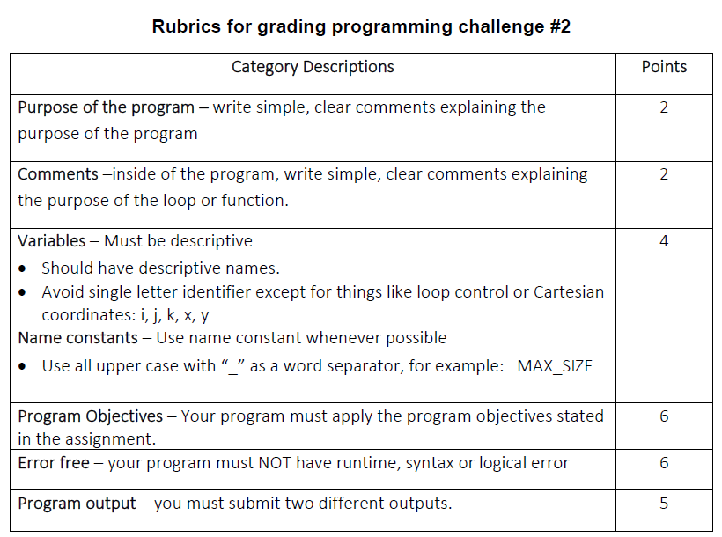

**Copy and paste your program (source) code and the outputs after this line**

**+++++++++++++++++++++++++++++++++++++++++++++++++++++++++++++++++++++++++++++**

/*Erik Gonzalez

CO SCI 575

FindLargestSmallesIndex.cpp

This program displays 15 integers in a range from 0-20.

The program will find and display:

The last largest element and its position,

The first smallest element and its position.

*/

#include <iostream>

#include <ctime>

using namespace std;

void printArray(const int array[], int size);

int lastLargestIndex(const int array[], int size);

int firstSmallestIndex(const int array[], int size);

int main()

{

const int SIZE = 15;

int array[SIZE];

unsigned int seed;

seed = time(0);

srand(seed);

//loop to generate the 15 random numbers

for (int i = 0; i < SIZE; i++)

{

array[i] = rand() % 20 + 0;

}

printArray(array, SIZE);

int lastLargest = lastLargestIndex(array, SIZE);

cout << "\n\nThe largest element in this list is " << array[lastLargest] << " at the position [" << lastLargest << "]" << endl;

int firstSmall = firstSmallestIndex(array, SIZE);

cout << "The smallest element in this list is " << array[firstSmall] << " at the position [" << firstSmall << "]" << endl;

system("pause");

return 0;

}

//Prints the array of 15 numbers randomly generated

void printArray(const int array[], int size)

{

cout << "List elements: ";

for (int i = 0; i < size; i++)

{

cout << array[i] << " ";

}

}

/*Goes through the array and finds which numbers are the

last largest and in what position on the array it is located. */

int lastLargestIndex(const int array[], int size)

{

int index = 0;

for (int i = 0; i < size; i++)

{

if (array[i] >= array[index])

{

index = i;

}

}

return index;

}

/*Goes through the array and find which numbers are the

first smallest and in what position on the array it is located. */

int firstSmallestIndex(const int array[], int size)

{

int index = 0;

for (int i = 0; i < size; i++)

{

if (array[i] < array[index])

{

index = i;

}

}

return index;

}

**Outputs:**

List elements: 5 15 11 19 19 16 16 17 9 11 19 6 7 17 11

The largest element in this list is 19 at the position [10]

The smallest element in this list is 5 at the position [0]

Press any key to continue . . .

List elements: 9 11 2 1 17 12 17 13 18 8 19 0 16 5 6

The largest element in this list is 19 at the position [10]

The smallest element in this list is 0 at the position [11]

Press any key to continue . . .

List elements: 0 0 17 6 1 4 15 9 5 3 5 9 11 16 13

The largest element in this list is 17 at the position [2]

The smallest element in this list is 0 at the position [0]

Press any key to continue . . .

List elements: 16 2 16 18 9 2 18 13 10 10 10 18 4 12 4

The largest element in this list is 18 at the position [11]

The smallest element in this list is 2 at the position [1]

Press any key to continue . . .